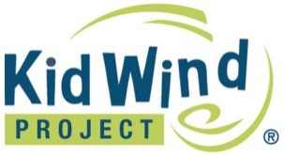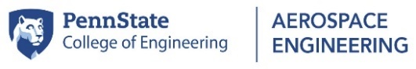

Call for KidWind: Using Wind to Harness the Power of Young Minds

MC900280814[1]**Presented by Dr. Susan Stewart**

**and Ashley Rapsinski (CSATS)**

**December 4, 2017 (9:00 am – 3:00 pm)**

**Saint Francis University**

Think you or your class has what it takes to build the most efficient, functional, and innovative wind turbine? Try your luck at the KidWind Challenge! Be creative, have fun, and apply your knowledge of wind energy to win cool prizes.

**When students participate in a KidWind Challenge they will:**

* **Discover the promise and limitations of wind energy technology**
* **Design, build, and test a functional creative wind turbine**
* **Compete with their peers in a supportive environment**

Wind is the fastest growing energy resource in the United States today and in this workshop you will engage in activities that will introduce you to the science behind wind energy while putting easy-to-use tools in your hands. You will participate in hands-on activities you can use with your students to get them excited about the KidWind Challenge.

Classroom inquiries of wind energy science, challenges, and benefits are powerful vehicles to expose students to “difficult-to-hold-onto” concepts like energy conversion and transfer, electricity generation, and our energy future.

This workshop will go “beyond pinwheels” with investigations of turbine

blade and generator designs that encourage and demand analytical thinking. With the potential to explore aspects of wind development from turbine and generator design to wind-wildlife interactions to how public perception impacts wind technology, you and your colleagues will leave inspired by the wide array of classroom and grade level adaptations that will work for you and your students. With applications for middle level and high school educators alike, you’ll leave the workshop with the knowledge, skills, and resources needed to introduce students to wind energy concepts.

**Maximum enrollment is 24**, so register on-line now to reserve a spot. If the class is full, be sure to sign up for the waiting list!

**For more information contact Ashley Rapsinski at 814-865-1713 or email** [**adb236@psu.edu**](mailto:adb236@psu.edu)**.**

This publication is available in alternative media on request. Penn State encourages qualified persons with disabilities to participate in its programs and activities. If you anticipate needing any type of accommodation or have questions about the physical access provided, please contact Ashley Rapsinksi at [adb236@psu.edu](mailto:adb236@psu.edu) in advance of your participation or visit. Penn State is an equal opportunity, affirmative action employer, and is committed to providing employment opportunities to all qualified applicants without regard to race, color, religion, age, sex, sexual orientation, gender identity, national origin, disability or protected veteran status. U.Ed. EDU 18-26

This publication is available in alternative media on request. Penn State encourages qualified persons with disabilities to participate in its programs and activities. If you anticipate needing any type of accommodation or have questions about the physical access provided, please contact Ashley Rapsinksi at [adb236@psu.edu](mailto:adb236@psu.edu) in advance of your participation or visit. Penn State is an equal opportunity, affirmative action employer, and is committed to providing employment opportunities to all qualified applicants without regard to race, color, religion, age, sex, sexual orientation, gender identity, national origin, disability or protected veteran status. U.Ed. EDU 18-12